Preliminary model for laser projection kinematics

Owen Lu

Electroimpact Inc.

owenl@electroimpact.com

*Abstract*—This document details the calculations that were done to form the basis which the absolute orientation and position of the laser projector can be solved using measured positions on a plane and galvanometer angular inputs.

# Introduction

This project has been undertaken in order to hopefully develop better solving algorithms for the laser scanners. It has been historically noted that registration order of calibration points can create performance variations. This is not ideal as the input data set should result in one solution describing the location and orientation of the system.

# Axis definitions

The construction of the laser projector allows good choices for the axes to be made in order to simplify calculations. The rotational axes are assumed orthogonal to one another from one another.

We select the first stage mirror to have rotational axis along the Z-axis while the second stage mirror has axis along the X-axis. Thus, the first stage mirror rotates about the origin.

# Reference coordinate kinematics

Assume that the mirror is a mathematical plane. The laser ray vector is then assumed to undergo a reflective transformation when passing through the plane.

Using mirror angles, we wish to determine the laser ray leaving the second mirror within the projector coordinates, and eventually the absolute reference coordinates.

Selection of axes: (some stuff here)

Suppose that $\hat{u}={\left[\begin{matrix}1 & 0 & 0\end{matrix}\right]}^{T}$ which represents the laser. Given angle $θ_{1}$, the smallest angle between the plane and the X-axis, the reflection transformation can be applied.

Since the mirror rotates along the Z-axis, we can use the rotation transformation matrix in two dimensions to find the x-y components.

$$\hat{u}'={\left[\begin{matrix}\cos\left(2θ_{1}\right) & \sin\left(2θ_{1}\right) & 0\end{matrix}\right]}^{T}$$

The first line ray is given by the below equation.

$$L_{1}:\left[\begin{matrix}-t_{1}/(2\sin\left(θ_{1}\right)) \\ 0 \\ 0\end{matrix}\right]+s\left[\begin{matrix}cos⁡(2θ_{1}) \\ \sin\left(2θ_{1}\right) \\ 0\end{matrix}\right]$$

The second axis is assumed to be a line parallel to the x-axis emanating from ${\left[\begin{matrix}0 & y_{0} & z_{0}\end{matrix}\right]}^{T}$.

$$L_{2}:\left[\begin{matrix}0 \\ y_{0} \\ z_{0}\end{matrix}\right]+v\left[\begin{matrix}1 \\ 0 \\ 0\end{matrix}\right]$$

If the plane contained the axis the equation would be given by the below equation



Now since the vector $\hat{u}'$ does not lie in the z-y plane, we cannot use the same trick to find $\hat{u}''$. An equation to find the vector after reflection about a plane with normal vector $\hat{n}$ is given below. All quantities are expected to be normalized.

$$r=d-2\left(d⋅n\right)n̂$$

Suppose that $θ_{2}$ is the smallest angle between the second plane and the Y-axis.

Then the second normal vector $\hat{n}$ can be written in terms of $θ_{2}$

$$\hat{n}={\left[\begin{matrix}0 & -sin⁡(θ_{2}) & cos⁡(θ_{2})\end{matrix}\right]}^{T}$$

Performing the computation and simplification gives $u^{''}$

$${\hat{u}}^{''}=\left[\begin{matrix}\cos\left(2θ_{1}\right) \\ \sin\left(2θ_{1}\right)cos⁡(2θ_{2}) \\ \sin\left(2θ_{1}\right)\sin\left(2θ_{2}\right)\end{matrix}\right]$$

$$p={\left[\begin{matrix}\operatorname{Lcot}\left(2θ_{1}\right) & L & 0\end{matrix}\right]}^{T}$$

Suppose that we wish to model the projection of the laser on $z=k$.

We can generate some plot with the following equations with $θ_{1},θ_{2}$ pairs.

$$x=\cot\left(2θ_{1}\right)\left(L+k\csc{(2θ_{2})}\right)$$

$$y=L+k\cot{(2θ_{2})}$$

Using $L=0.05$ and k $=3$ the below projection plot was generated.

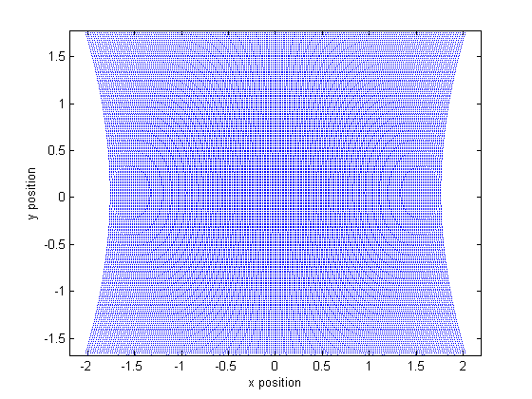

Figure 1 – Projection points using $30<θ_{1},θ_{2}<60$

Therefore, the line used to solve for the intersection of the laser and the surface is given below.

$$R: p+s\hat{u}''$$

# Angular error analysis

Since there are two angular inputs, a natural source of error is error due to input error.

The standard deviation of the projection can be approximated using the partial derivatives.

$$\frac{∂x}{∂θ_{1}}=-2\left(L+K\csc{(2θ_{2})}\right)\csc^{2}\left(2θ_{1}\right)$$

$$\frac{∂x}{∂θ_{2}}=2Kcot\left(2θ_{1}\right)cot\left(2θ_{2}\right)\csc\left(2θ_{2}\right)$$

$$\frac{∂y}{∂θ_{2}}=-2K\csc^{2}\left(2θ_{2}\right)$$

Error measured in distance from the intended point and the actual should be bounded

$$δx=\sqrt{{\left(\frac{∂x}{∂θ_{1}}δθ_{1}\right)}^{2}+{\left(\frac{δx}{δθ_{2}}δθ_{2}\right)}^{2}}$$

$$δy=\frac{∂y}{∂θ_{2}}δθ_{2}$$

# Coordinate transform

Since the coordinates of the calibration points are assumed to be known in the absolute frame, the parameters describing the translation and rotation of the galvanometer frame must be calculated.

Suppose the galvanometer has a coordinate frame with origin at $r$ and rotation describe by unit quaternion $q$.

The vector from origin $r$ to $p$ is projected on to rotated basis unit vectors $e_{1},e_{2},e_{3}$. Let $e_{i}^{'}$ represent rotated vector $e_{i}$.

$$e_{i}^{'}=q⊗e_{i}⊗\overline{q}$$

The location of the absolute calibration points can then be describe as below.

$$x^{'}=\vec{rp}⋅e_{1}^{'}$$

$$y^{'}=\vec{rp}⋅e_{2}'$$

$$z^{'}=\vec{rp}⋅e_{3}'$$

There are then 7 parameters that describe the system, thus, at least 7 equations must be formulated to calculate the values.

We can transform all points into $xyz^{'}$ coordinates using the transformation listed above and see discrepancy with respect to $r,q$.

$$q_{1}^{2}+q_{2}^{2}+q_{3}^{2}+q_{4}^{2}=1$$

In theory for each point there exists $s_{i}$ such that

$$p_{2}+s_{i}{\hat{u}}^{''}=\overline{x}'$$

Therefore

$${\hat{u}}^{''}=\left[\begin{matrix}\cos\left(2θ_{1}\right) \\ \sin\left(2θ_{1}\right)cos⁡(2θ_{2}) \\ \sin\left(2θ_{1}\right)\sin\left(2θ_{2}\right)\end{matrix}\right]$$

$$p_{2}={\left[\begin{matrix}\operatorname{Lcot}\left(2θ_{1}\right) & L & 0\end{matrix}\right]}^{T}$$

$$\left(\begin{matrix}L\cot\left(2{θ_{1}}_{i}\right) \\ L \\ 0\end{matrix}\right)+s_{i}\left(\begin{matrix}\cos\left(2{θ_{1}}_{i}\right) \\ \sin\left(2{θ_{1}}_{i}\right)\cos\left(2{θ_{2}}_{i}\right) \\ \sin\left(2{θ_{1}}_{i}\right)\sin\left(2{θ_{2}}_{i}\right)\end{matrix}\right)=\overline{q}⊗\vec{rp}⊗q$$

We can also write quaternion rotation as $R_{q}$ a 3x3 matrix.

$$\left(\begin{matrix}L\cot\left(2{θ_{1}}_{i}\right) \\ L \\ 0\end{matrix}\right)+s_{i}\left(\begin{matrix}\cos\left(2{θ_{1}}_{i}\right) \\ \sin\left(2{θ_{1}}_{i}\right)\cos\left(2{θ_{2}}_{i}\right) \\ \sin\left(2{θ_{1}}_{i}\right)\sin\left(2{θ_{2}}_{i}\right)\end{matrix}\right)=R(\overline{q})\vec{rp}$$

Therefore, find $\overline{q}$ and $r$

$$R(q)=\left[\begin{matrix}1-2q_{3}^{2}-2q_{4}^{2} & 2\left(q_{2}q_{3}-q_{4}q_{1}\right) & 2(q_{2}q_{4}+q_{3}q_{1}) \\ 2(q_{2}q_{3}+q_{4}q_{1}) & 1-2q_{2}^{2}-q_{4}^{2} & 2(q_{2}q_{4}-q_{2}q_{1}) \\ 2\left(q_{2}q_{4}-q_{3}q_{1}\right) & 2(q_{3}q_{4}+q_{2}q_{1}) & 1-2q_{2}^{2}-2q_{3}^{2}\end{matrix}\right]$$

$$\left(\begin{matrix}L\cot\left(2{θ_{1}}_{i}\right) \\ L \\ 0\end{matrix}\right)+s_{i}\left(\begin{matrix}\cos\left(2{θ_{1}}_{i}\right) \\ \sin\left(2{θ_{1}}_{i}\right)\cos\left(2{θ_{2}}_{i}\right) \\ \sin\left(2{θ_{1}}_{i}\right)\sin\left(2{θ_{2}}_{i}\right)\end{matrix}\right)=R\left(\overline{q}\right)\left(p-r\right)$$

$$R\left(\overline{q}\right)p=p^{'}$$

$$R\left(\overline{q}\right)r=r^{'}$$

$$p_{2}+su^{''}-p^{'}=r'$$

# Three point ray solution

Instead of simultaneously solving 7 non-linear equations for translation $\overline{r}$ and unit quaternion $q$ an alternative exact method is used

However, we can use the following scenario to find one such solution for $r_{0}$ and $q$ so that two points are automatically intersected.

Although I have not proven this, for non-parallel $L_{1},L_{2}$ I believe it is possible to find $r,q$ such that the distance from virtual point ${\overline{x}}_{v}$ is equal to two calibrations $p_{1},p_{2}$, thus forming an isosceles triangle in some plane. In fact there should be infinite such planes rotated around arbitrary angles around axis $\vec{p_{1}p_{2}}$.

One solution to such a point is given by the equation below. We simply set the virtual point on the blab la plane stuff and stuff.

Within this plane, there exists some arc that describes all such points that satisfy the 2 ray equation.

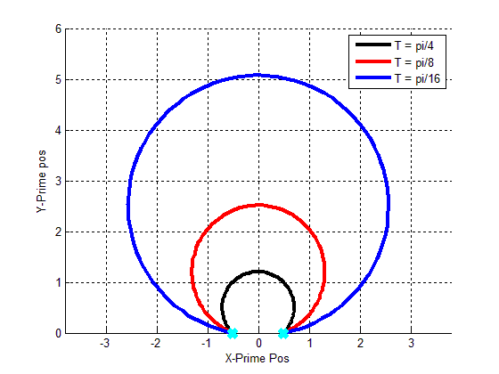

It is obvious that rotation around $\vec{p_{1}p_{2}}$ are also solutions. Call this rotation transformation $q(\vec{p_{1}p_{2}},θ_{bullshit}$).

This geometry of the circle rotated around $\vec{p_{1}p_{2}}$ forms a spindle torus solution space with inner surface removed. An example of a spindle torus is shown below.

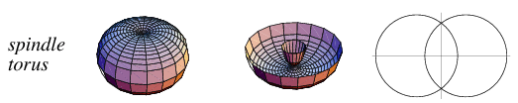

Therefore, knowing some solution $r_{0},q_{0}$ which is easy to calculate given the isosceles construction. Then we find two rotations $q_{n_{v}}$ and $q_{p}$ that solve the system